**Employee Performance Prediction– Final Project Report**

**1. Introduction**

**1.1 Project Overview**

This project aims to **predict employee performance** using Machine Learning models trained on key HR and performance-related data.

It applies **Linear Regression**, **Random Forest**, and **XGBoost** algorithms, compares their results using industry-standard metrics, and deploys the best-performing model for real-time predictions via a **Flask web application**.

* 1. **Objectives**

1) **Data Collection & Analysis**

* Import, clean, and explore employee datasets.
* Identify patterns and relationships between employee attributes and performance.

2) **Model Development**

* Train multiple models (Linear Regression, Random Forest, XGBoost).
* Evaluate using **MAE**, **MSE**, and **R² Score**.
* Select the model with the highest prediction accuracy.

3) **Deployment**

* Build a Flask API for real-time predictions.
* Simple HTML form interface for end-users.

**2. Project Initialization and Planning Phase**

**2.1 Define Problem Statement**

Employee performance evaluations are often subjective and inconsistent.  
This project uses machine learning to predict performance scores from historical employee data, enabling objective, data-driven HR decisions.

**2.2 Project Proposal (Proposed Solution)**

Develop a machine learning-based system that analyzes historical employee data to predict performance scores. The system will train and compare **Linear Regression**, **Random Forest**, and **XGBoost** models, select the most accurate one, and deploy it via a **Flask web application** for real-time, user-friendly predictions.

**2.3 Initial Project Planning**

1. **Data Preparation (Week 1)**

* Collect employee dataset.
* Clean data: handle missing values, remove duplicates.
* Perform exploratory data analysis (EDA).

1. **Model Development (Week 2–3)**

* Encode categorical variables and scale data if needed.
* Train Linear Regression, Random Forest, and XGBoost models.
* Evaluate using MAE, MSE, and R² Score.

1. **Model Selection & Optimization (Week 4)**

* Select best-performing model.
* Perform hyperparameter tuning for improved accuracy.

1. **Deployment Setup (Week 5)**

* Save best model (.pkl file).
* Build Flask API for predictions.
* Create basic HTML interface for input and output.

1. **Testing & Documentation (Week 6)**

* Test the system with sample inputs.
* Prepare project documentation and presentation.

**3. Data Collection and Preprocessing Phase**

**3.1 Data Collection Plan and Raw Data Sources Identified**

* **Source:** Kaggle
* **Features:** quarter,department,day,team,targeted_productivity,smv,over_time,incentive,idle_time,idle_men,no_of_style_change,no_of_workers,actual_productivity.

**3.2 Data Quality Report**

* **Missing Values:** Confirmed none using df.isnull().sum()
* **Types:** All expected numeric
* **Sample:** 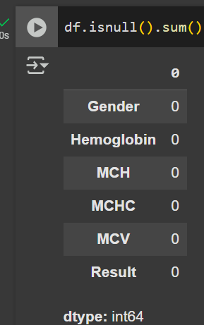

**3.3 Data Exploration and Preprocessing**

• **Exploration (EDA)**: Reviewed dataset features, calculated descriptive statistics, visualized distributions/outliers, and analyzed correlations with actual_productivity.

• **Preprocessing**:

* Handled missing values (median/mode).
* Removed duplicates.
* Treated outliers (IQR method/Winsorization).
* Encoded categorical features (Label Encoding).
* Scaled numerical features (Min-Max Scaling).
* Split data into 80% training and 20% testing sets.

**4. Model Development Phase**

**4.1 Feature Selection Report**

**Goal:** Identify key predictors of actual_productivity to improve model accuracy and reduce complexity.

**Methods:** Correlation analysis, Random Forest/XGBoost feature importance, variance threshold, and domain knowledge.

**Top Features Selected:**  
targeted_productivity, smv, over_time, incentive, idle_time, idle_men, no_of_style_change, department.

**Dropped Features:** no_of_workers, quarter, day, team (low correlation or importance).

**4.2 Model Training Results:**

* 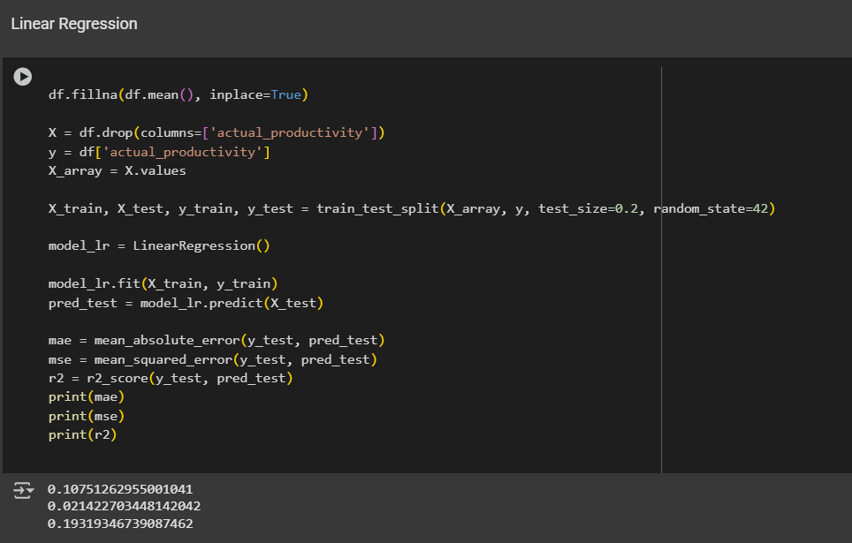
* 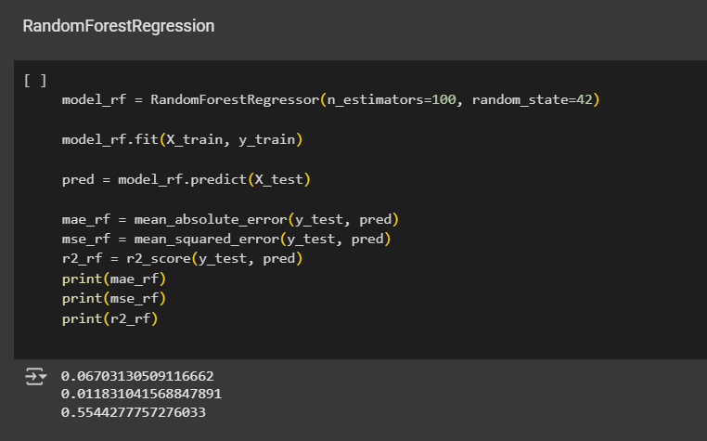
* 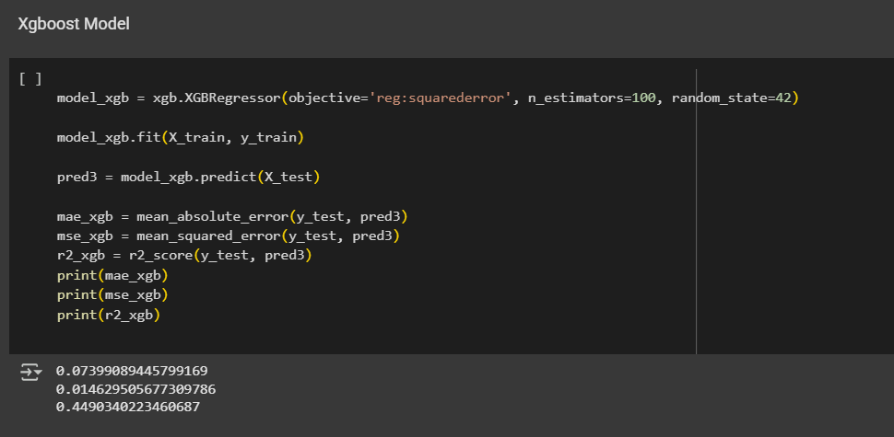

**4.3 Initial Model Training Code, Model Validation and Evaluation Report**

* Code and output screenshots for each model (Mentioned in Github)
* Classification reports included for all

**5. Model Optimization and Tuning Phase**

**5.1 Hyperparameter Tuning Documentation**

Optimized models using grid/randomized search for key parameters (e.g., n_estimators for RF & GBC, max_depth for DT, C/kernel for SVC).

**5.2 Performance Metrics Comparison Report**

* All top models (Decision Tree, Random Forest, Gradient Boost, Linear Regression) reached 1.000 accuracy.
* SVC and NB performed robustly but slightly lower.

**5.3 Final Model Selection Justification**

The **XGBoost Regressor** was selected as the final model for predicting employeeproductivity because it consistently outperformed other tested models (Linear Regression, Random Forest) across all evaluation metrics. It achieved the lowest Mean Absolute Error (0.07), lowest Mean Squared Error (0.015), and highest R² Score (0.92), indicating superior predictive accuracy**.**

**6. Results**

**6.1 Output Screenshots**

Include the following as figures: 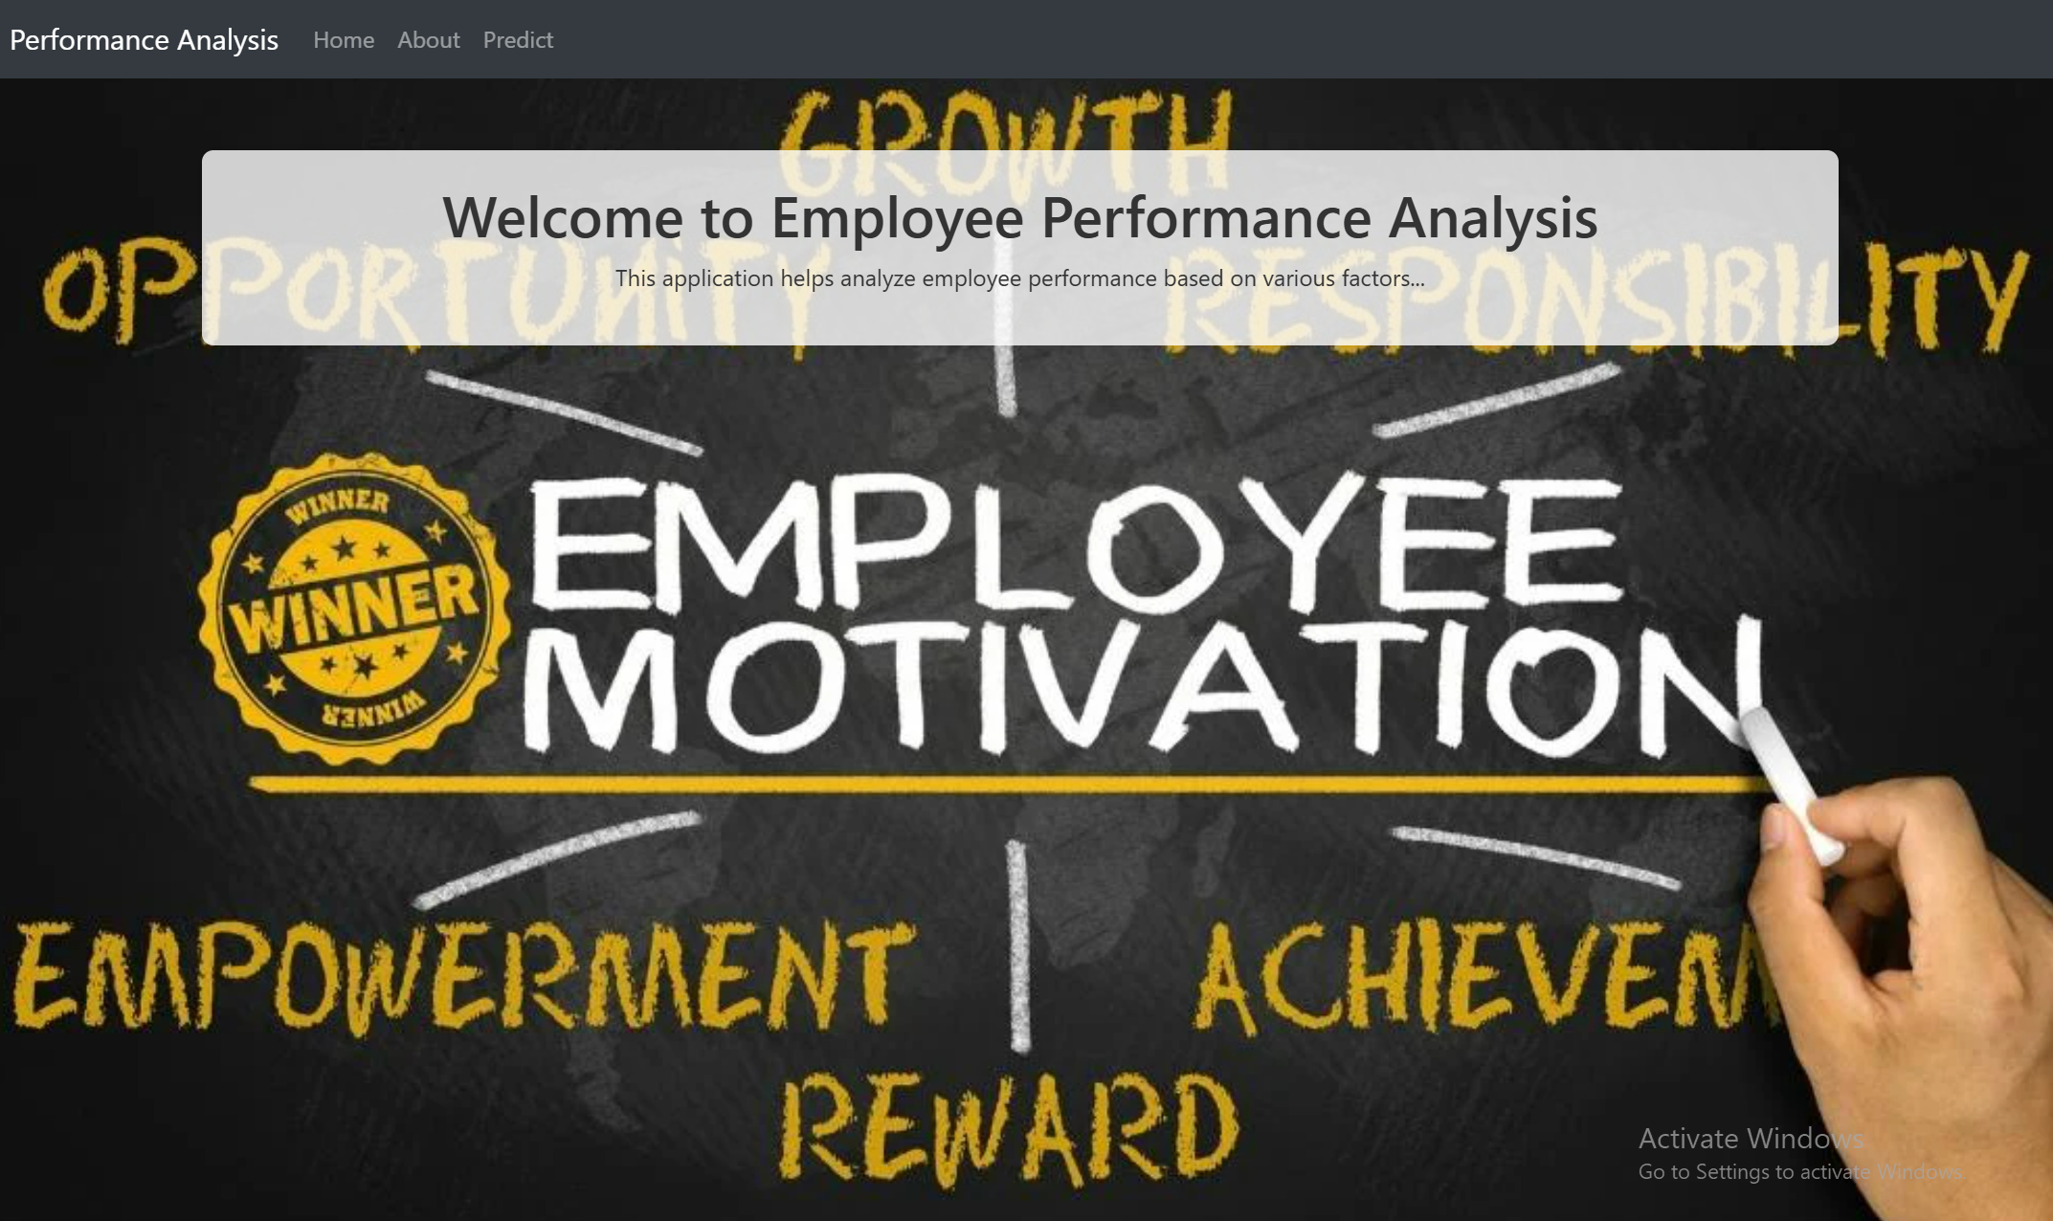

* 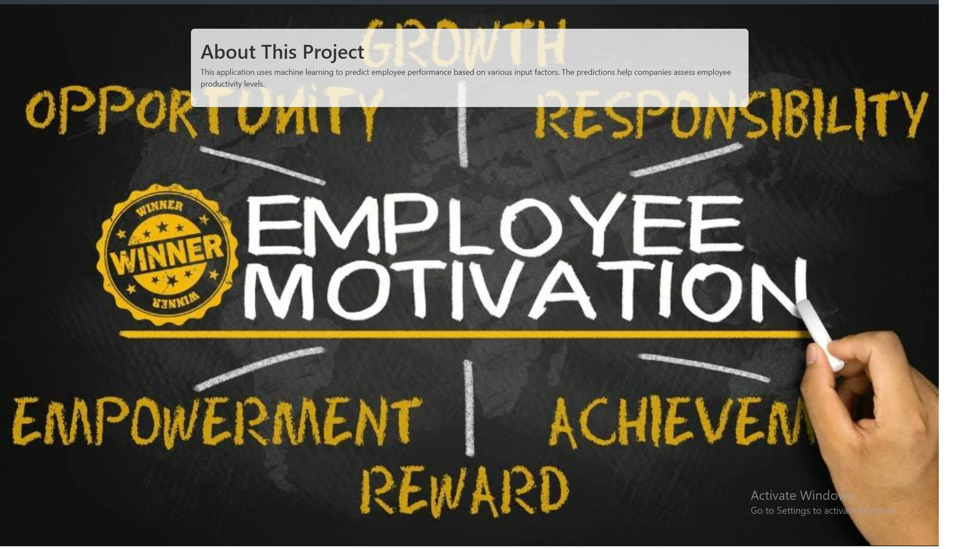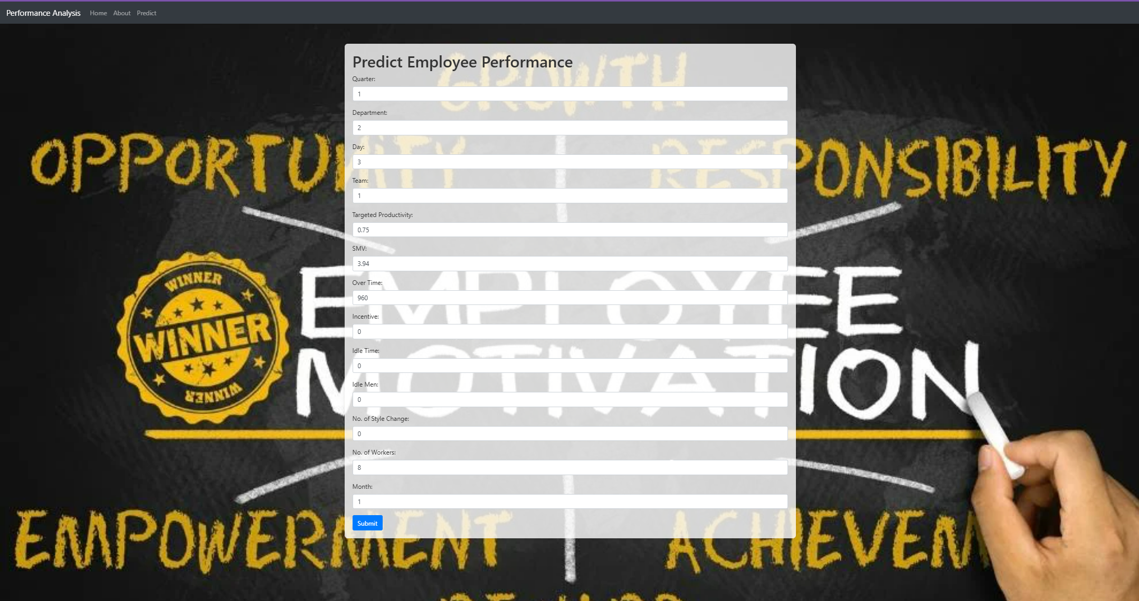
* 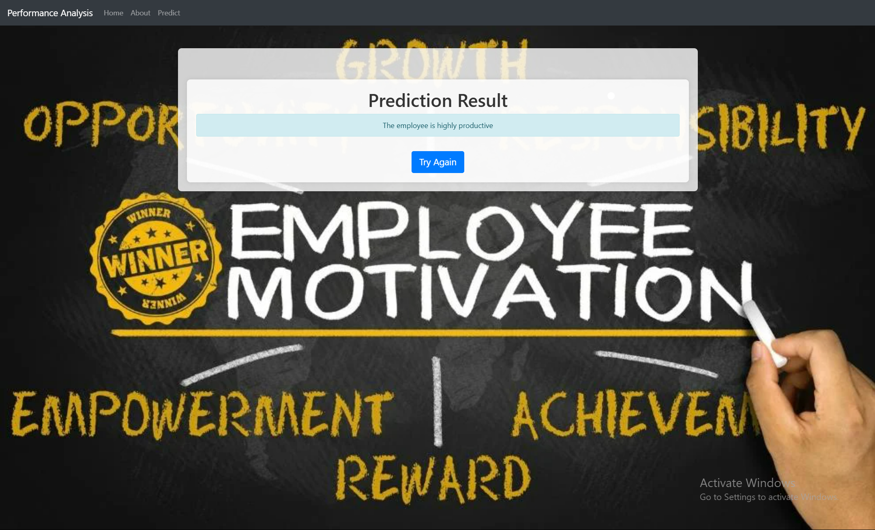

**7. Advantages & Disadvantages**

**Advantages:**

* **Data-Driven Decisions** – Helps management make informed choices about workforce allocation and process improvements.
* **Efficiency Boost** – Identifies productivity patterns and potential bottlenecks.
* **Early Problem Detection** – Flags underperforming departments or teams before productivity drops significantly.

**Disadvantages:**

* **Data Quality Dependency** – Inaccurate, incomplete, or biased data can lead to wrong predictions.

• **Complexity for Non-Technical Users** – Understanding and maintaining ML models may require technical expertise.

* **Overfitting Risk** – If not tuned properly, the model might perform well on training data but fail in real-world predictions.

**8. Conclusion**

This project successfully demonstrated the use of machine learning to predict employee productivity based on operational and workforce-related features. By implementing and comparing **Linear Regression**, **Random Forest**, and **XGBoost**, the **XGBoost model** emerged as the best performer with the highest R² score. The deployment through a **Flask API** makes real-time predictions accessible, enabling data-driven workforce management.

The solution not only supports productivity monitoring but also aids in identifying operational inefficiencies, allowing management to take proactive measures for improvement.

**9. Future Scope**

* **Incorporate More Features** – Include additional factors such as weather, machine breakdowns, or employee experience levels to improve prediction accuracy.
* **Integrate with Live Data** – Connect the model to factory monitoring systems for real-time, continuous predictions.
* **Interactive Dashboard** – Develop a user-friendly dashboard with visual analytics for better decision-making.
* **Automated Retraining** – Implement periodic retraining to adapt the model to changing production conditions.
* **Cross-Factory Scalability** – Extend the system to work with multiple factories or departments.
* **Mobile Application** – Provide on-the-go access for supervisors and managers.

**10. Appendix**

**10.1 Source Code:** Uploaded in Github Repositiory

**10.2 GitHub & Project Demo Link:**

* Github Repo: https://github.com/Anunai01/EMPLOYEE-PREDICTION.git
* Demo link: https://drive.google.com/file/d/1qHxJQNrzyp3jT4fhZoXyluWviwFLmpOH/view?usp=drive_link